36. Scenario: You are a data analyst working for a finance company. Your team is interested in

analyzing the variability of stock prices for a particular company over a certain period. The

company's stock data includes the closing prices for each trading day of the specified period.

Question: Your task is to build a Python program that reads the stock data from a CSV file,

calculates the variability of stock prices, and provides insights into the stock's price movements.

Code:

import pandas as pd

import numpy as np

import matplotlib.pyplot as plt

# Load the stock data from the CSV file

file_path =r"C:\Users\jampa\Downloads\stock_price_data.csv"

df = pd.read_csv(file_path, parse_dates=['Date'])

def analyze_stock_variability(df):

# Calculate daily returns (percent change)

df['Daily Return (%)'] = df['Adj Close'].pct_change() * 100

# Calculate basic statistics

avg_price = df['Adj Close'].mean()

max_price = df['Adj Close'].max()

min_price = df['Adj Close'].min()

volatility = df['Daily Return (%)'].std()

print(f"Average Adjusted Close Price: ${avg_price:.2f}")

print(f"Maximum Adjusted Close Price: ${max_price:.2f}")

print(f"Minimum Adjusted Close Price: ${min_price:.2f}")

print(f"Price Volatility (Std Dev of Daily Returns): {volatility:.2f}%")

# Plot the adjusted close prices

plt.figure(figsize=(9,3))

plt.plot(df['Date'], df['Adj Close'], marker='o', color='blue', linewidth=2)

plt.title('Stock Price Movement')

plt.xlabel('Date')

plt.ylabel('Adjusted Close Price ($)')

plt.xticks(rotation=45)

plt.grid(True, linestyle='--', alpha=0.6)

plt.show()

# Run the analysis

analyze_stock_variability(df)

output:

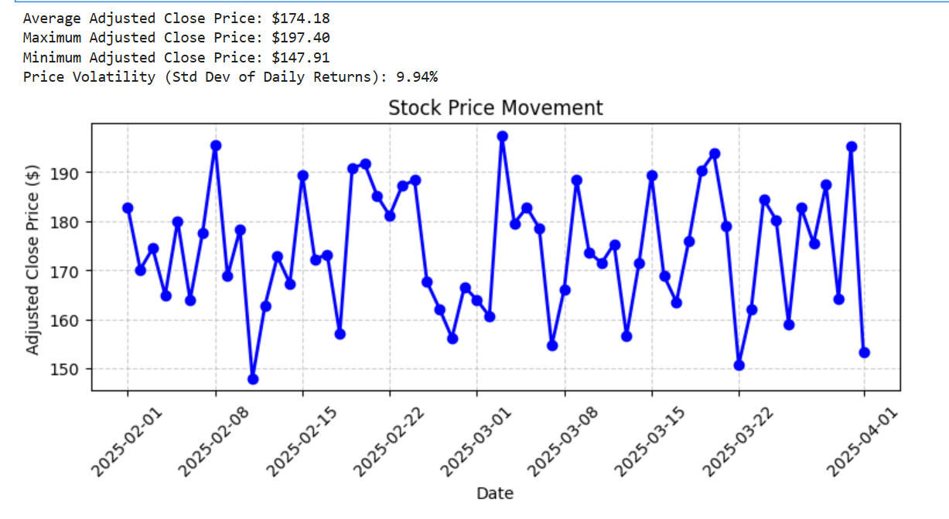

Dataset:

|  |  |  |  |  |  |  |
| --- | --- | --- | --- | --- | --- | --- |
| Date | Open | High | Low | Close | Adj Close | Volume |
| 2/1/2025 | 183.23 | 183.6 | 181.06 | 183.16 | 182.79 | 3903847 |
| 2/2/2025 | 171.23 | 171.26 | 170.46 | 171.11 | 170.12 | 1831623 |
| 2/3/2025 | 177.79 | 182.6 | 173.7 | 174.96 | 174.42 | 2444228 |
| 2/4/2025 | 167.16 | 171.91 | 165.05 | 165.11 | 164.88 | 3157227 |
| 2/5/2025 | 179.58 | 182.54 | 178.45 | 181.21 | 180 | 1254419 |
| 2/6/2025 | 164.15 | 165.74 | 161.65 | 164.57 | 163.94 | 4557241 |
| 2/7/2025 | 173.85 | 178.4 | 173.44 | 177.91 | 177.59 | 2112570 |
| 2/8/2025 | 194.29 | 198.31 | 193.34 | 195.87 | 195.54 | 2370028 |
| 2/9/2025 | 168.68 | 169.64 | 167.36 | 169.37 | 168.76 | 4204595 |
| 2/10/2025 | 179.52 | 181.67 | 175.04 | 180 | 178.3 | 2755150 |
| 2/11/2025 | 150.95 | 154.17 | 148.32 | 148.92 | 147.91 | 3232499 |
| 2/12/2025 | 164.73 | 164.89 | 163.88 | 163.98 | 162.75 | 4638015 |
| 2/13/2025 | 172.84 | 175.07 | 171.88 | 173.76 | 172.78 | 4707428 |
| 2/14/2025 | 169.31 | 172.25 | 165.49 | 168.91 | 167.24 | 3145187 |
| 2/15/2025 | 191.85 | 193.28 | 190.67 | 191.27 | 189.45 | 4979538 |
| 2/16/2025 | 169.29 | 173.56 | 168.33 | 172.5 | 172.23 | 1246971 |
| 2/17/2025 | 175.41 | 175.99 | 172.75 | 173.32 | 173.17 | 4585497 |
| 2/18/2025 | 157.92 | 159.28 | 157.21 | 157.26 | 157 | 2575355 |
| 2/19/2025 | 190.08 | 194.4 | 185.38 | 191.36 | 190.8 | 1594659 |
| 2/20/2025 | 196.06 | 200.53 | 192.58 | 192.9 | 191.64 | 2625284 |
| 2/21/2025 | 186.73 | 188.09 | 182.95 | 185.52 | 185.12 | 2924931 |
| 2/22/2025 | 182.71 | 185.24 | 179.87 | 182.28 | 181.07 | 4698438 |
| 2/23/2025 | 190.92 | 193.66 | 187.36 | 187.73 | 187.19 | 3083295 |
| 2/24/2025 | 188.13 | 188.59 | 184.92 | 188.31 | 188.29 | 1235227 |
| 2/25/2025 | 168.11 | 170.98 | 166.87 | 168.69 | 167.57 | 1005046 |
| 2/26/2025 | 160.51 | 163.44 | 156.49 | 162.87 | 162.11 | 2422251 |
| 2/27/2025 | 158.15 | 160.75 | 157.52 | 157.95 | 156.18 | 2074365 |
| 2/28/2025 | 168.76 | 169.46 | 166.46 | 168.47 | 166.6 | 2799676 |
| 3/1/2025 | 163.5 | 167.77 | 161.93 | 165.02 | 163.93 | 4930548 |
| 3/2/2025 | 158.25 | 162.34 | 157.67 | 160.81 | 160.59 | 3901875 |
| 3/3/2025 | 197.87 | 199.71 | 196.97 | 197.5 | 197.4 | 2698756 |
| 3/4/2025 | 180.48 | 181.93 | 179.38 | 180.44 | 179.52 | 4307064 |
| 3/5/2025 | 181.66 | 183.96 | 179.51 | 182.78 | 182.77 | 4912881 |
| 3/6/2025 | 178.42 | 179.5 | 177.1 | 178.63 | 178.53 | 2198860 |
| 3/7/2025 | 154.87 | 159.18 | 154.69 | 155.83 | 154.6 | 3898539 |
| 3/8/2025 | 166.9 | 167.06 | 165.09 | 166.92 | 166.04 | 3409691 |
| 3/9/2025 | 187.81 | 191.34 | 184.07 | 188.92 | 188.44 | 1625913 |
| 3/10/2025 | 174.13 | 177.13 | 170.18 | 175.2 | 173.63 | 2892701 |
| 3/11/2025 | 173.15 | 173.88 | 168.26 | 171.6 | 171.41 | 1232816 |
| 3/12/2025 | 172.61 | 176.79 | 169.8 | 175.87 | 175.32 | 3333056 |
| 3/13/2025 | 160.02 | 164.48 | 157.12 | 157.75 | 156.61 | 1511837 |
| 3/14/2025 | 170.02 | 171.97 | 168.79 | 171.83 | 171.37 | 2041248 |
| 3/15/2025 | 189.14 | 191.33 | 189.02 | 190.9 | 189.32 | 1525689 |
| 3/16/2025 | 170.49 | 170.66 | 167.06 | 170.57 | 168.87 | 3124842 |
| 3/17/2025 | 162.4 | 164.8 | 157.59 | 163.87 | 163.48 | 3820709 |
| 3/18/2025 | 175.63 | 179.02 | 172.13 | 176.6 | 176.03 | 3219302 |
| 3/19/2025 | 188.44 | 191.44 | 187.4 | 190.26 | 190.2 | 2613952 |
| 3/20/2025 | 194.61 | 194.88 | 190.44 | 194.58 | 193.75 | 3830788 |
| 3/21/2025 | 179.21 | 181.85 | 178.85 | 180.12 | 179.01 | 2660178 |
| 3/22/2025 | 151.95 | 153.46 | 151.57 | 152.65 | 150.72 | 4665090 |
| 3/23/2025 | 162.4 | 167.08 | 162.23 | 162.78 | 162.02 | 1473565 |
| 3/24/2025 | 181.75 | 185.46 | 179.99 | 185.05 | 184.44 | 4088322 |
| 3/25/2025 | 181.2 | 182.29 | 177.47 | 180.66 | 180.18 | 1793333 |
| 3/26/2025 | 160.4 | 160.84 | 160.33 | 160.68 | 159.06 | 1744962 |
| 3/27/2025 | 180.35 | 184.26 | 177.33 | 183.36 | 182.79 | 2539285 |
| 3/28/2025 | 181.09 | 184.45 | 176.97 | 177.33 | 175.41 | 1206532 |
| 3/29/2025 | 187.6 | 190.7 | 183.73 | 188.55 | 187.39 | 1743786 |
| 3/30/2025 | 166.48 | 167.78 | 165.28 | 166.14 | 164.22 | 2691231 |
| 3/31/2025 | 196.42 | 200.89 | 191.97 | 195.85 | 195.14 | 4314244 |
| 4/1/2025 | 154.84 | 155.18 | 153.06 | 154.41 | 153.22 | 1472314 |